EXPERIMENTNO19

DeterminationandplottingofAntennaEfficiency. Aim:
TodetermineandplotAntennaEfficiencyandtoEstimatethe efficiencybasedonradiatedandinputpower.

Softwarerequired:
- SCILABversion6.0.1

Program:
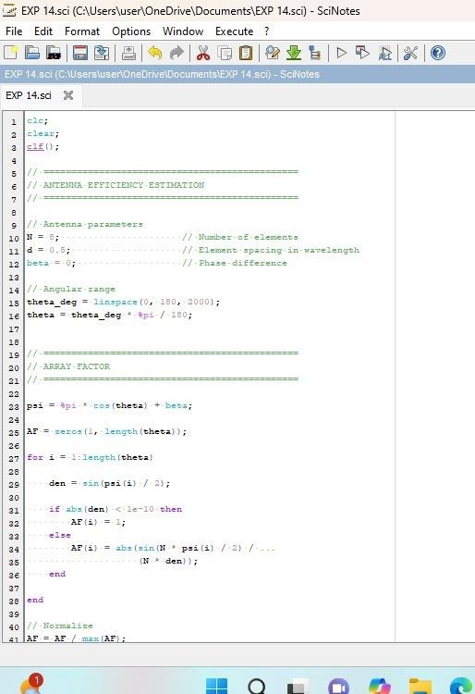

Output:
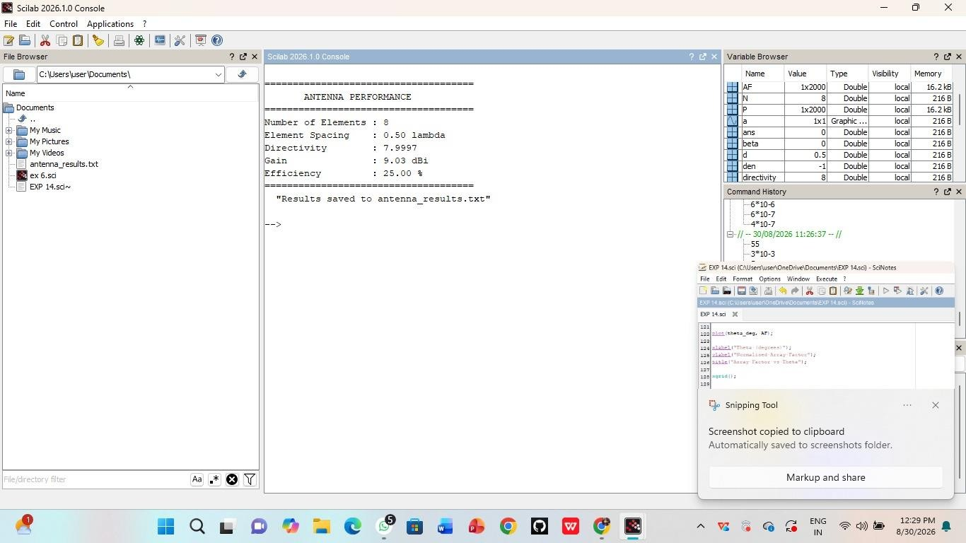

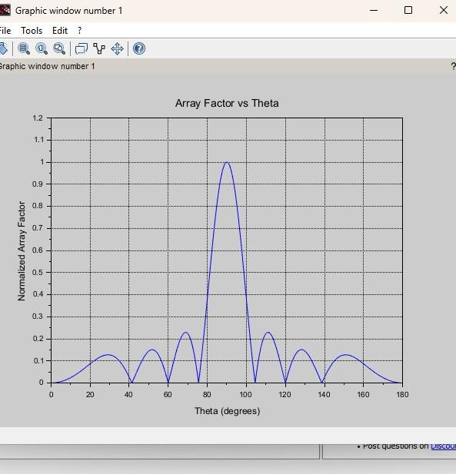

Program:
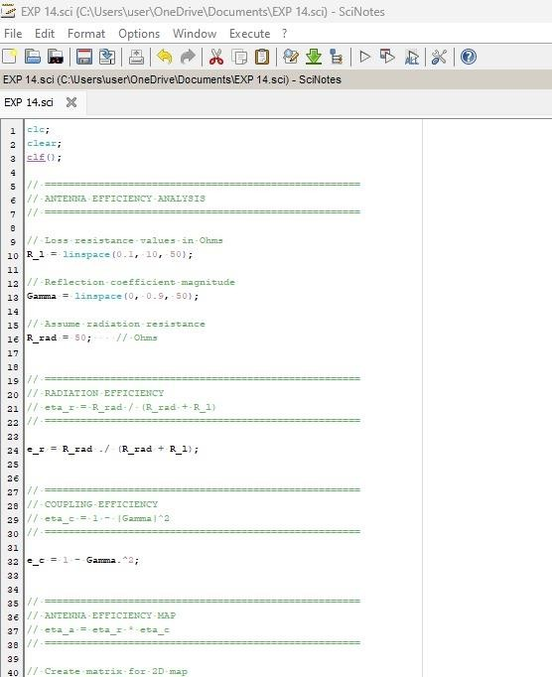

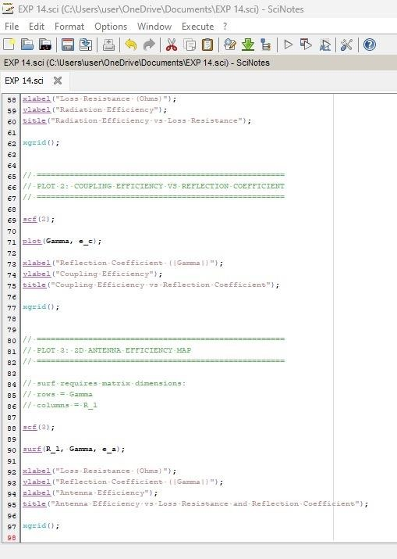

Output:
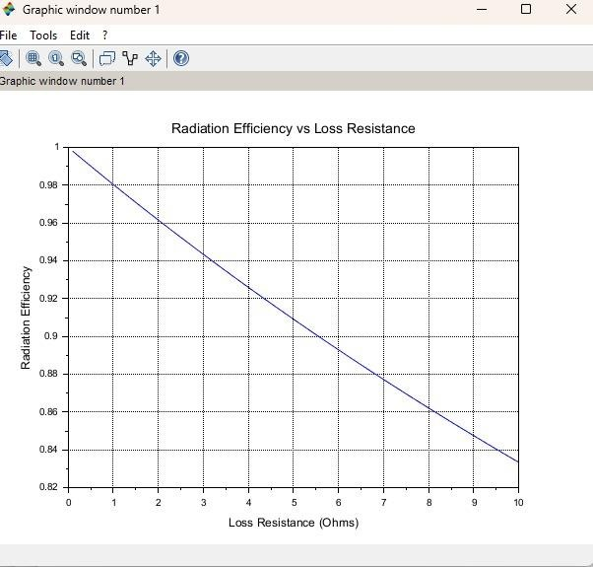

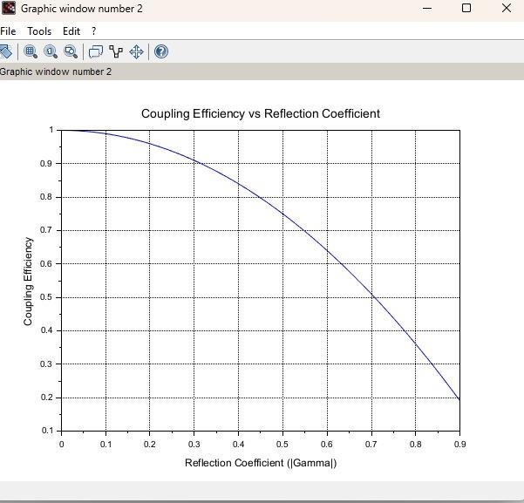

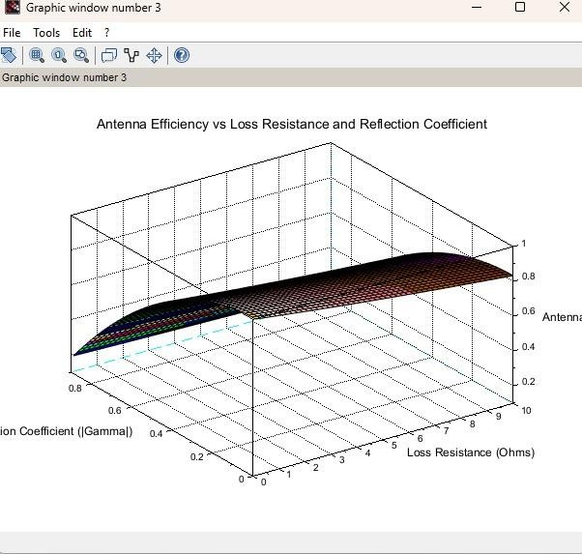

RESULT:
Theexperimentwasdoneandtheefficiency ofthegivenantennawas found. Different case studies were analyzed. These case studies highlightthepracticalimportanceofantennaefficiencyinvarious applications. For all systems, increasing radiation efficiency (minimizingpowerloss)andcoupling efficiency(ensuringimpedance matching)werecrucialforoptimizingantennaperformance.The calculationsshowthat,forpracticalsystems,smallimprovement

